# LAB # 14

**Objective: Assemble two input OR gates with the help of IC-7432 and verify their logic operation.**

**Equipment:**

* IC -7432
* logic probe
* Breadboard
* 5V DC Power Supply or Battery
* Connecting Wires

**Theory:**

An OR gate is a basic logic gate that outputs HIGH (1) when at least one of its inputs is HIGH (1). The logic expression for OR gate is:

### C = A+B

The truth table for a two-input OR gate is:

|  |  |  |
| --- | --- | --- |
| **INPUT A** | **INPUT B** | **OUTPUT C** |
| 0 | 0 | 0 |
| 0 | 1 | 1 |
| 1 | 0 | 1 |
| 1 | 1 | 1 |

**Procedure:**

* Determine pins of transistors according to their datasheet.
* Place both transistors on a breadboard.
* Assemble the circuit on the breadboard according to the circuit diagram.
* Verify the results against the OR gate truth table by setting input values.

**Truth Table Verification:**

|  |  |  |
| --- | --- | --- |
| **INPUT A** | **INPUT B** | **LED OUTPUT** |
| 0 | 0 | OFF |
| 0 | 1 | ON |
| 1 | 0 | ON |
| 1 | 1 | ON |

**Conclusion:**

The two-input OR gate was successfully assembled using discrete components, and the operation was verified by matching the output with the expected truth table.

**Circuit Diagram:**

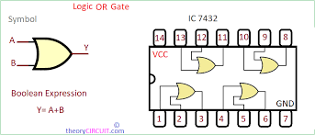

**POST LAB:**

1. How does the operation of the OR gate with transistors differ from its implementation using diodes?
2. What would happen if one of the transistors was faulty or incorrectly wired?
3. What will be the output of an OR gate if both of its inputs are at logic high?